## *SPRINT- 2*

|  |  |
| --- | --- |
| ***DATE*** | 05 NOVEMBER 2022 |
| ***TEAM ID*** | PNT2022TMID47483 |
| ***PROJECT NAME*** | GAS LEAKAGE DETECTION AND ALERTING |
| ***MAXIMUM MARKS*** | 20 |

***Step1: Install node red and open node red in command prompt***

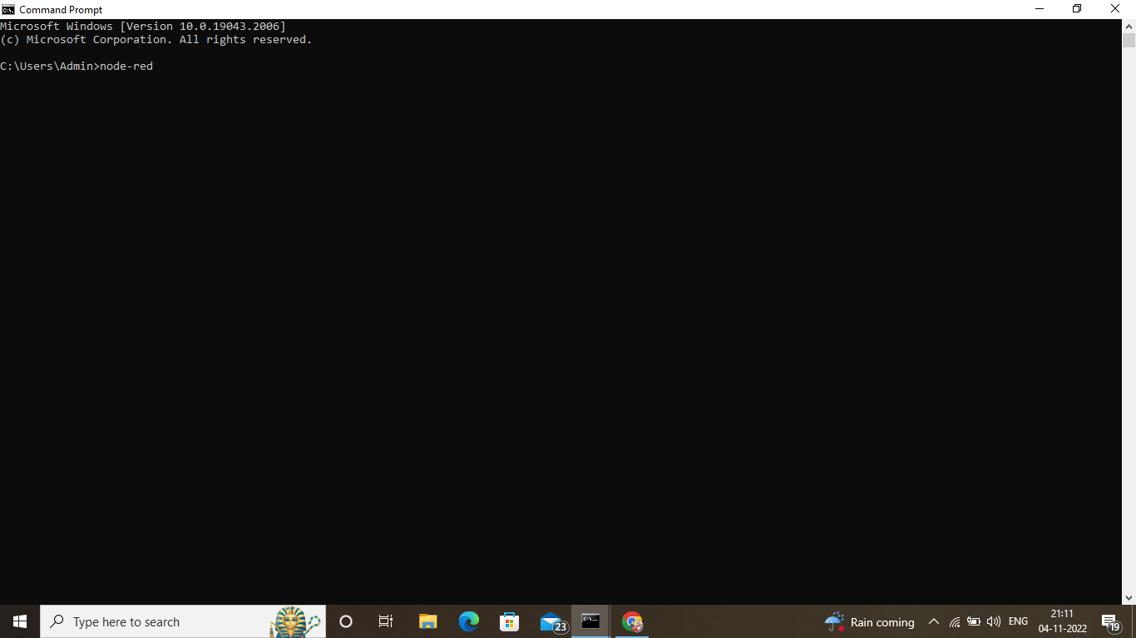

***Step 2: Select IBM IoT input in node***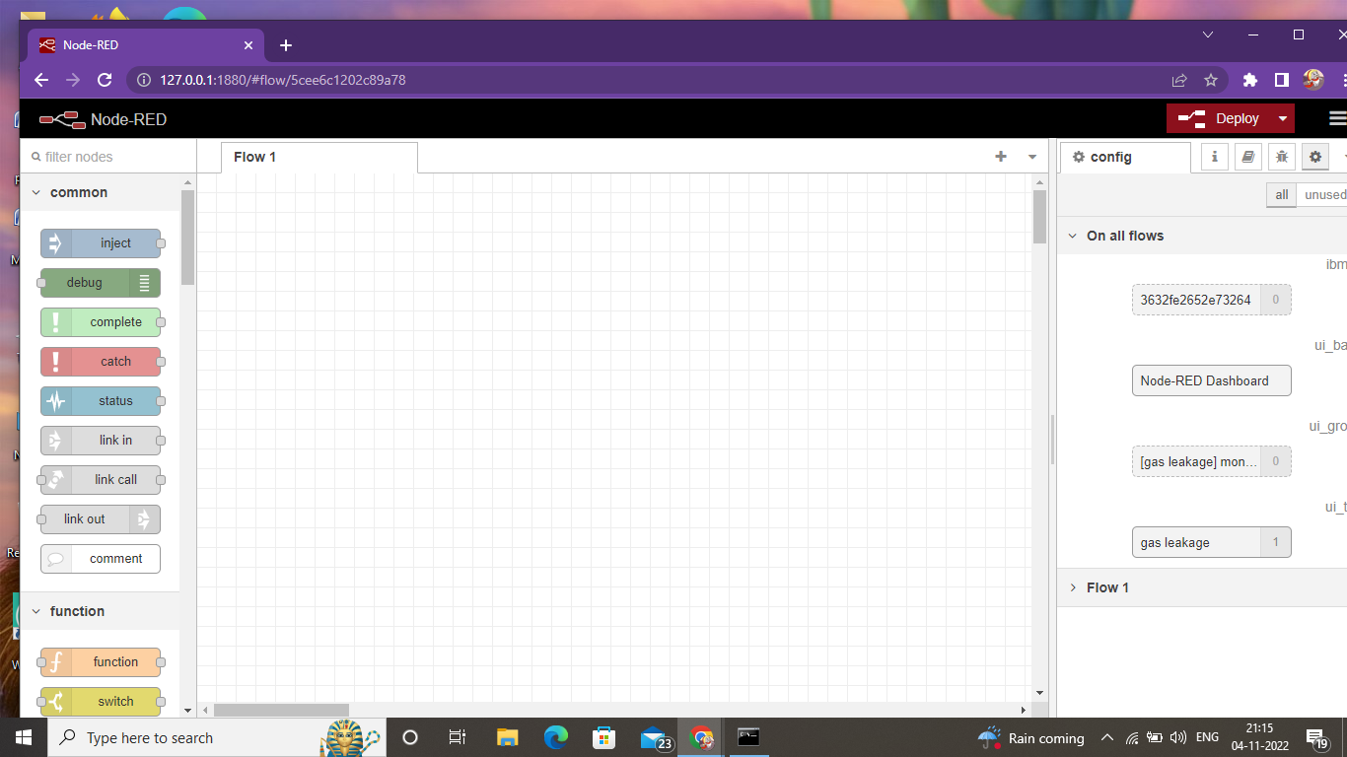

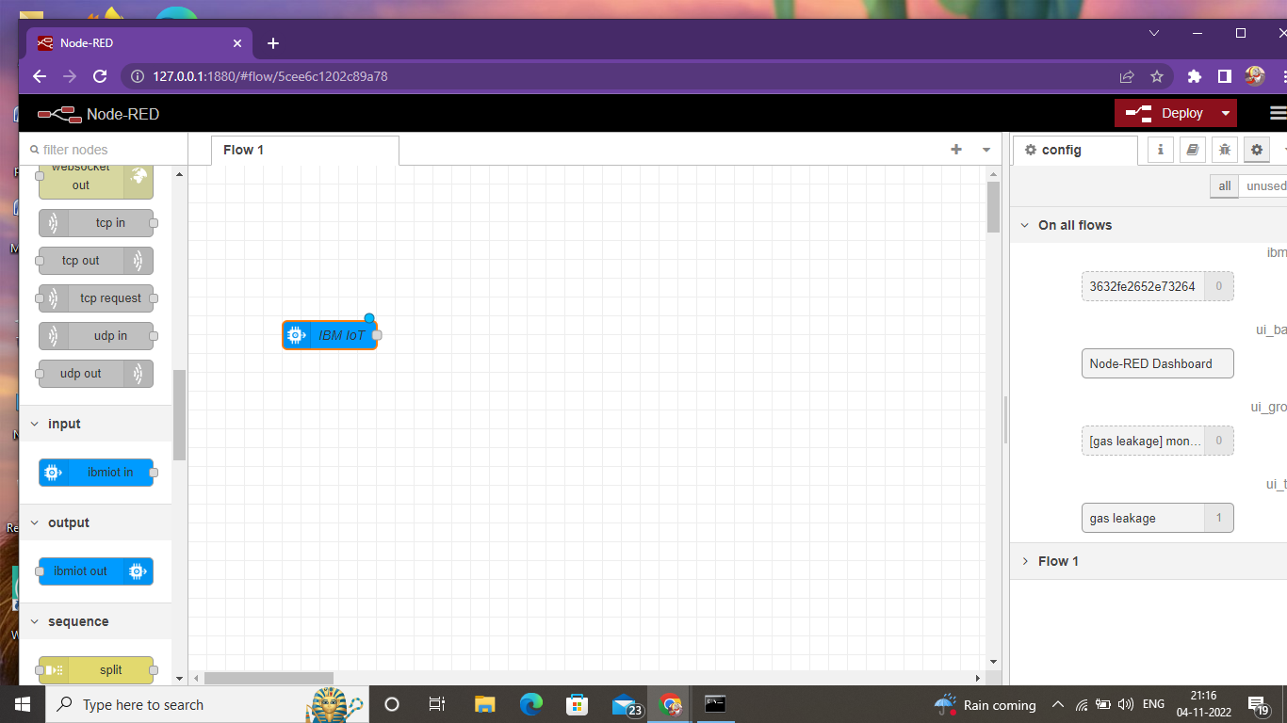

***Step 3: In IBM Watson platform, go to apps***

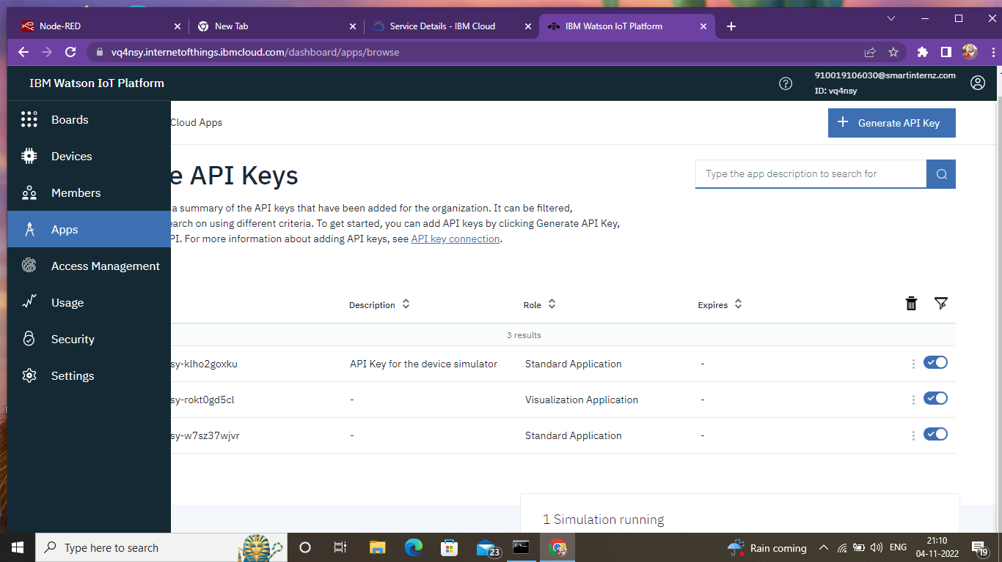

***Step 4: Click on generate API keys***

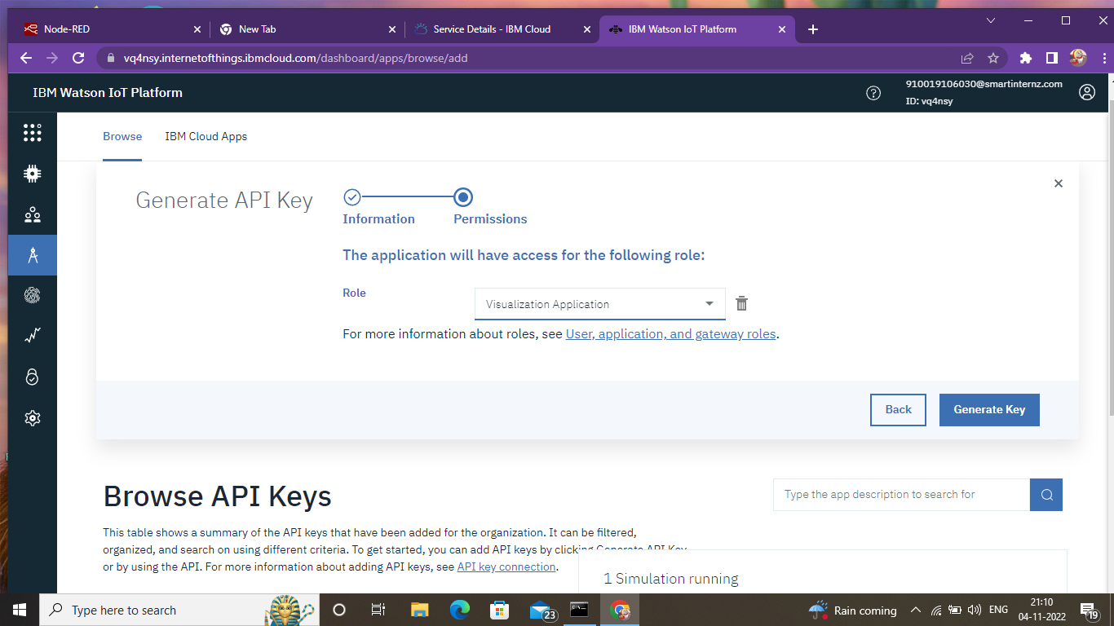

***Step 5: Generated API key Details***

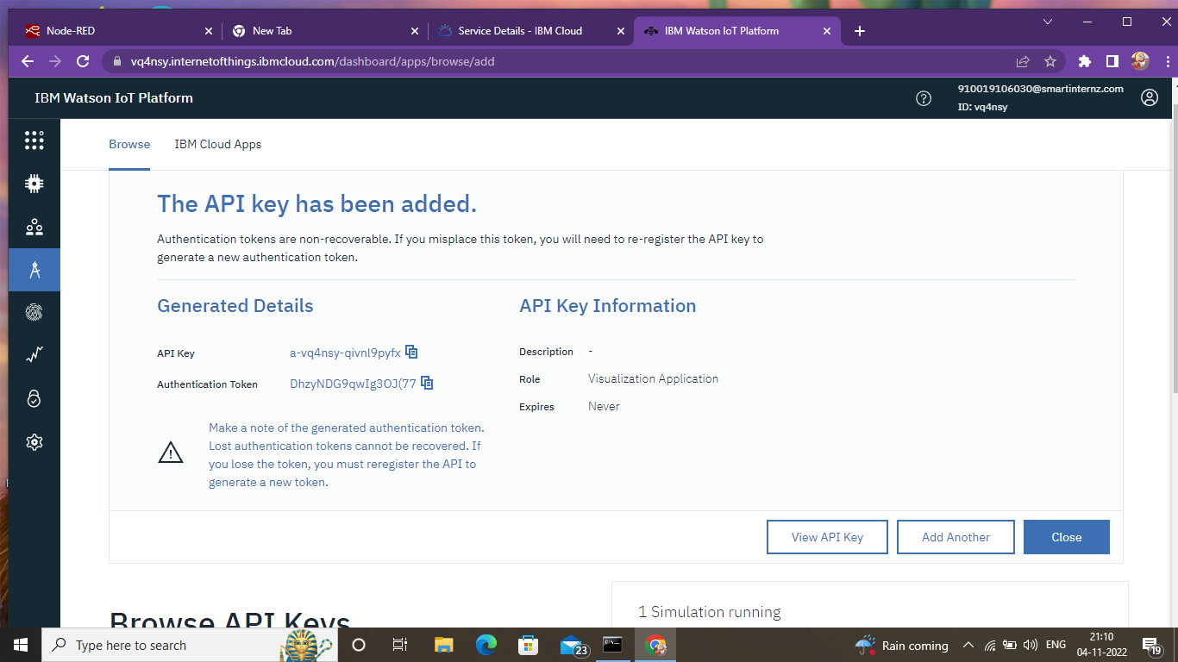

***Step6: Copy and paste the generated API key in node red***

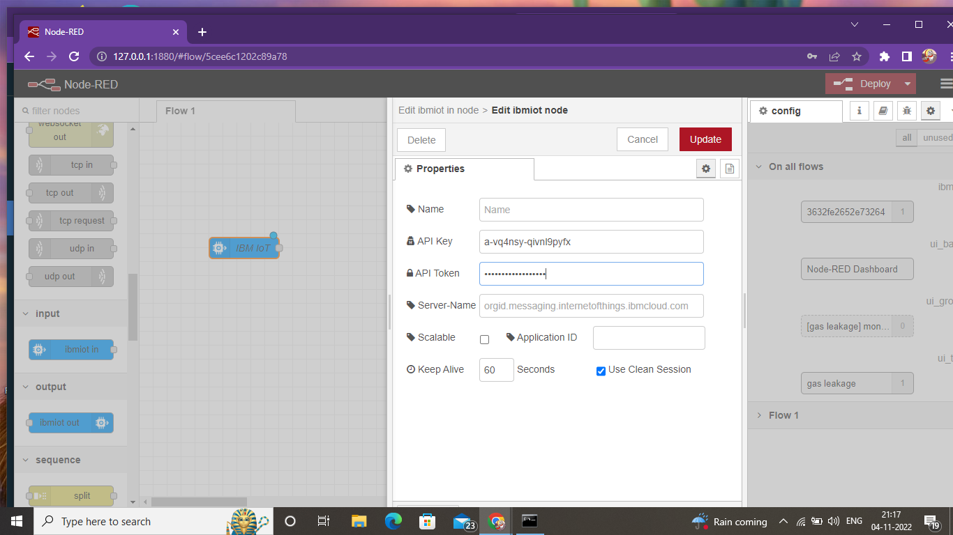

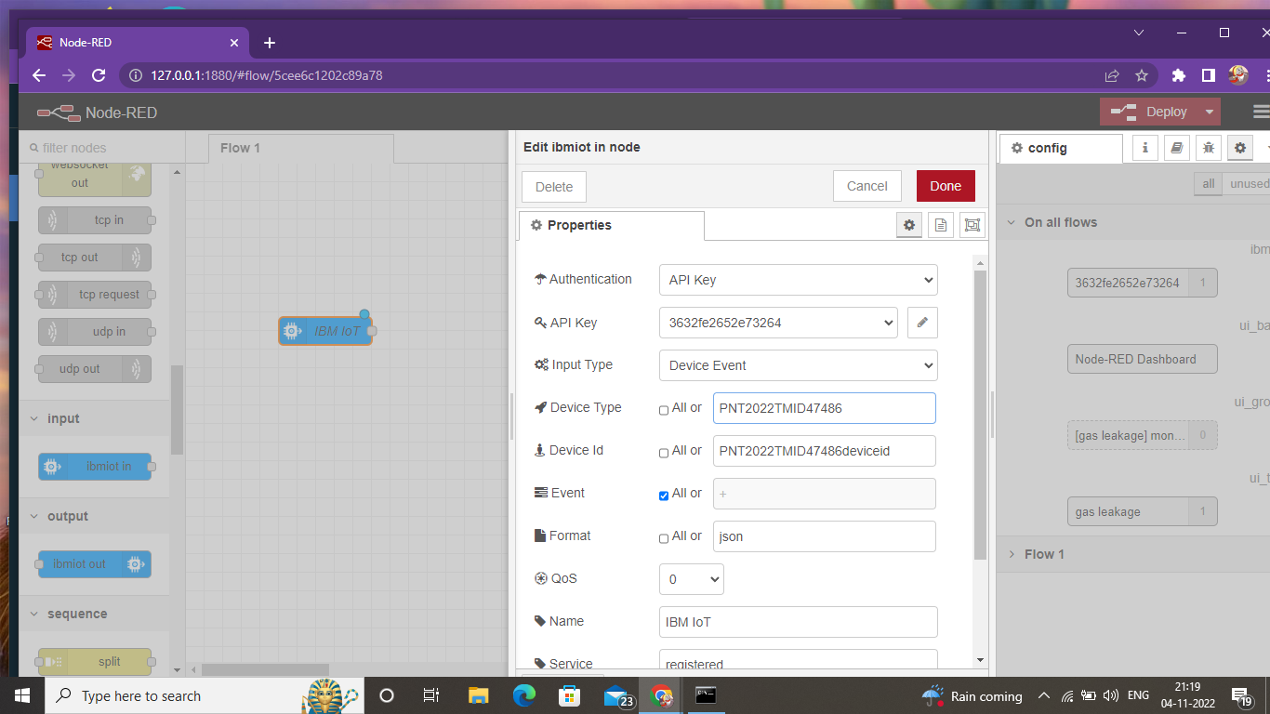

***Step 7:after completing all the details click in done button***

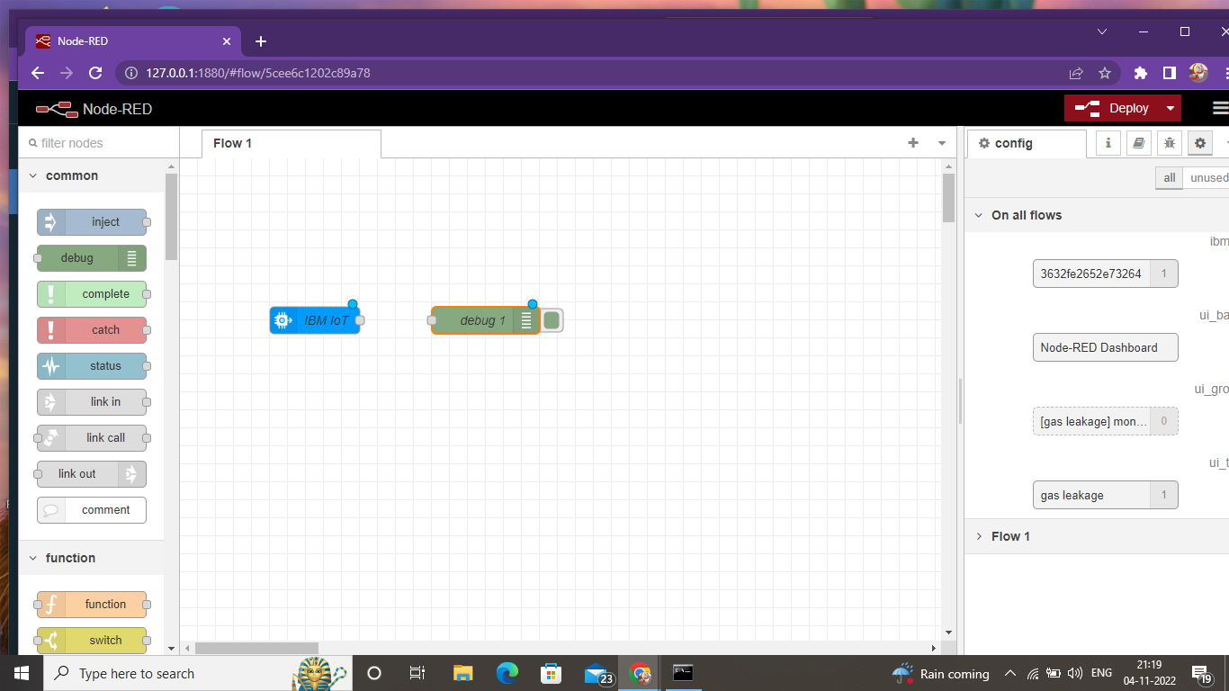

***Step 8:add debug to the IBM iot and rename as msg.payload and click on done.***

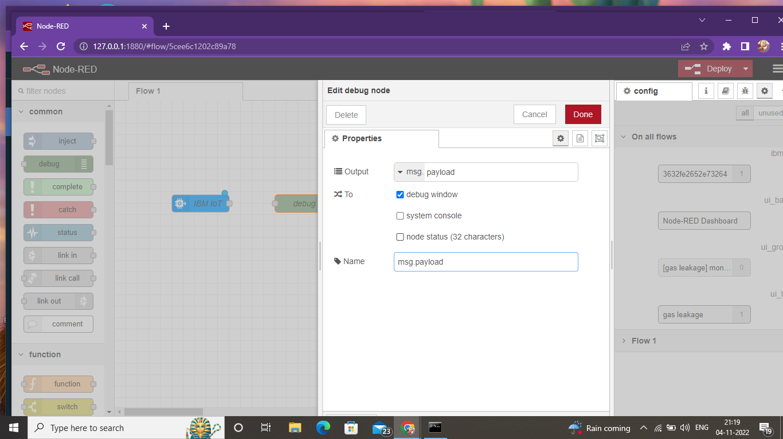

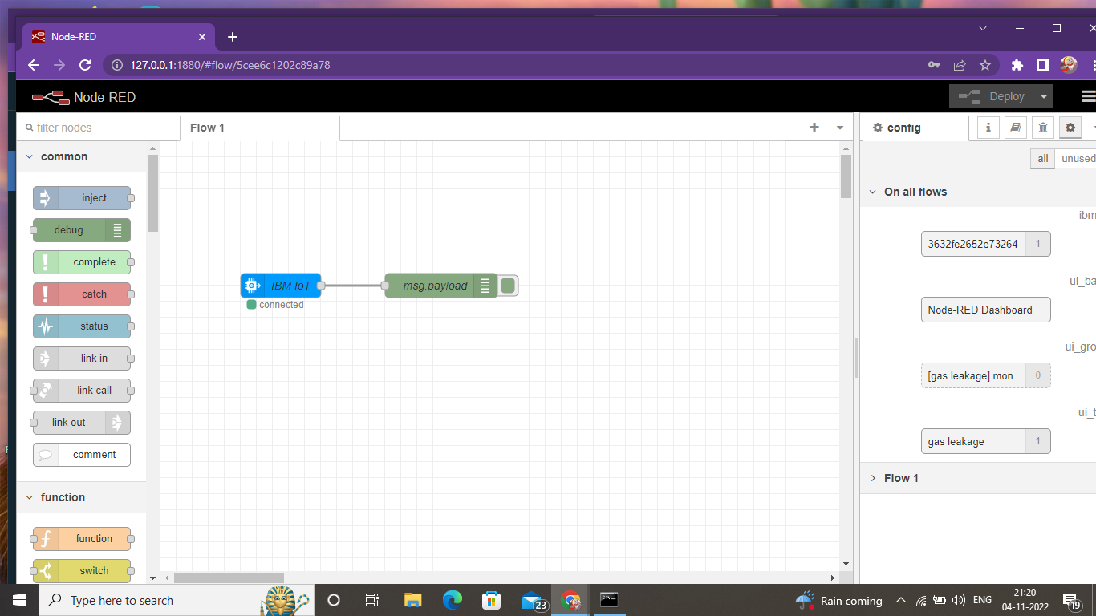

***Step 9: Click gauge from the dashboard node and fill the details***

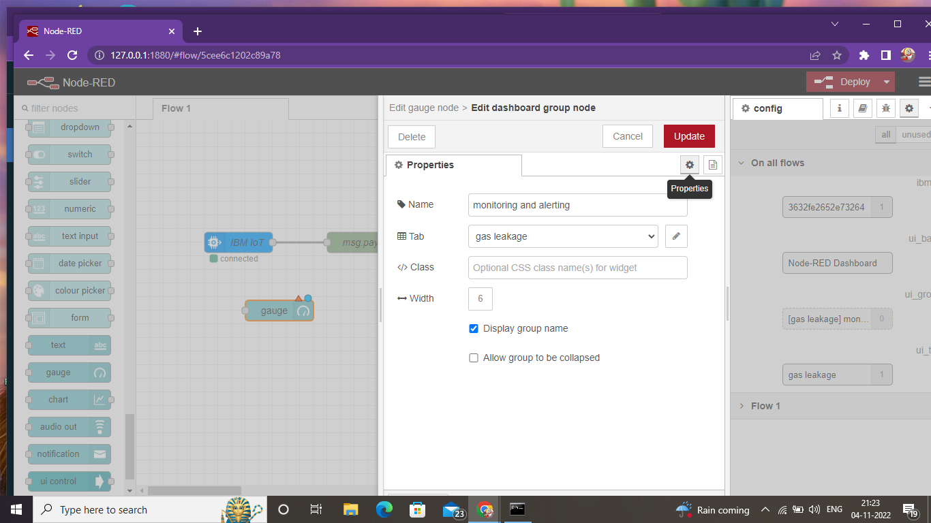

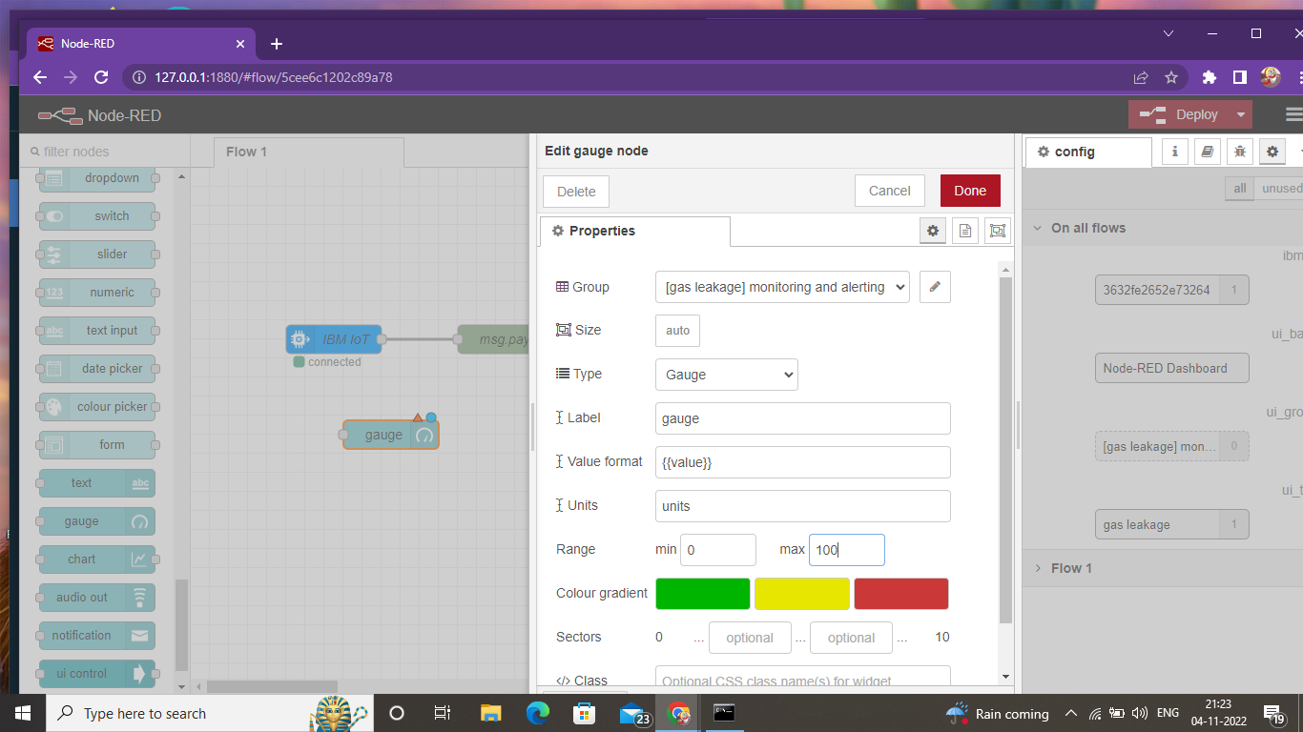

***Step 10: Add functions to the gauge***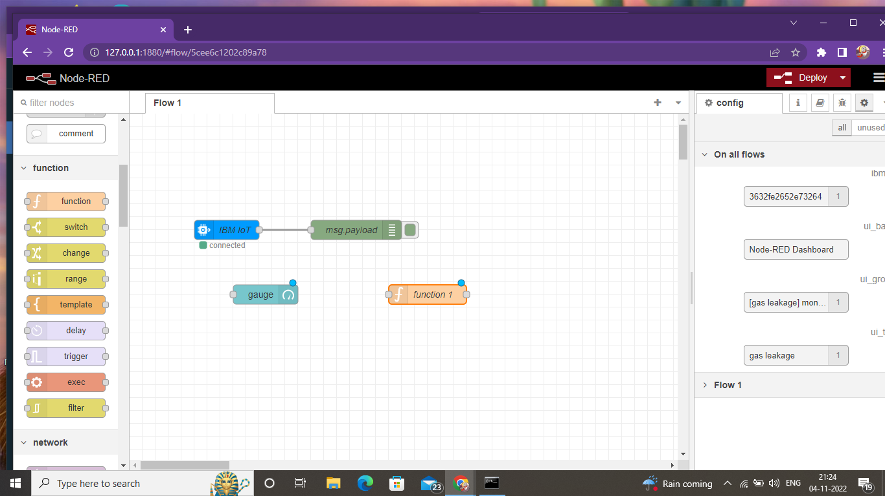

***Step 11: Check the values from debug messages***

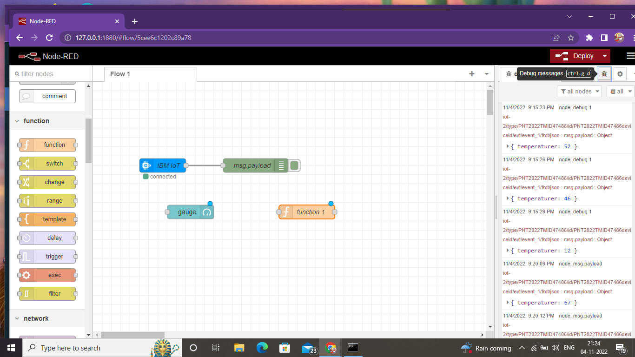

***Step 12: Edit function node***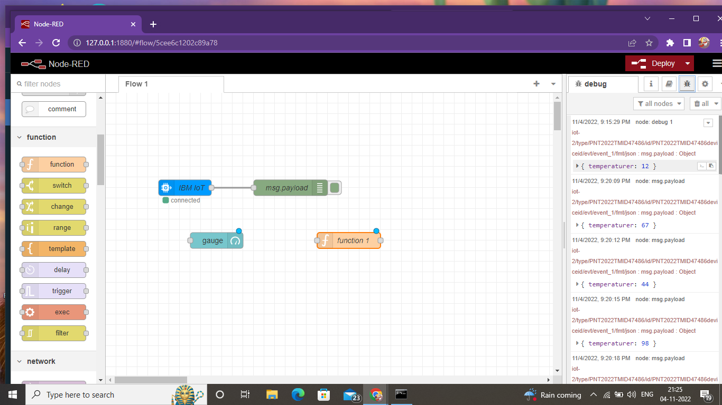

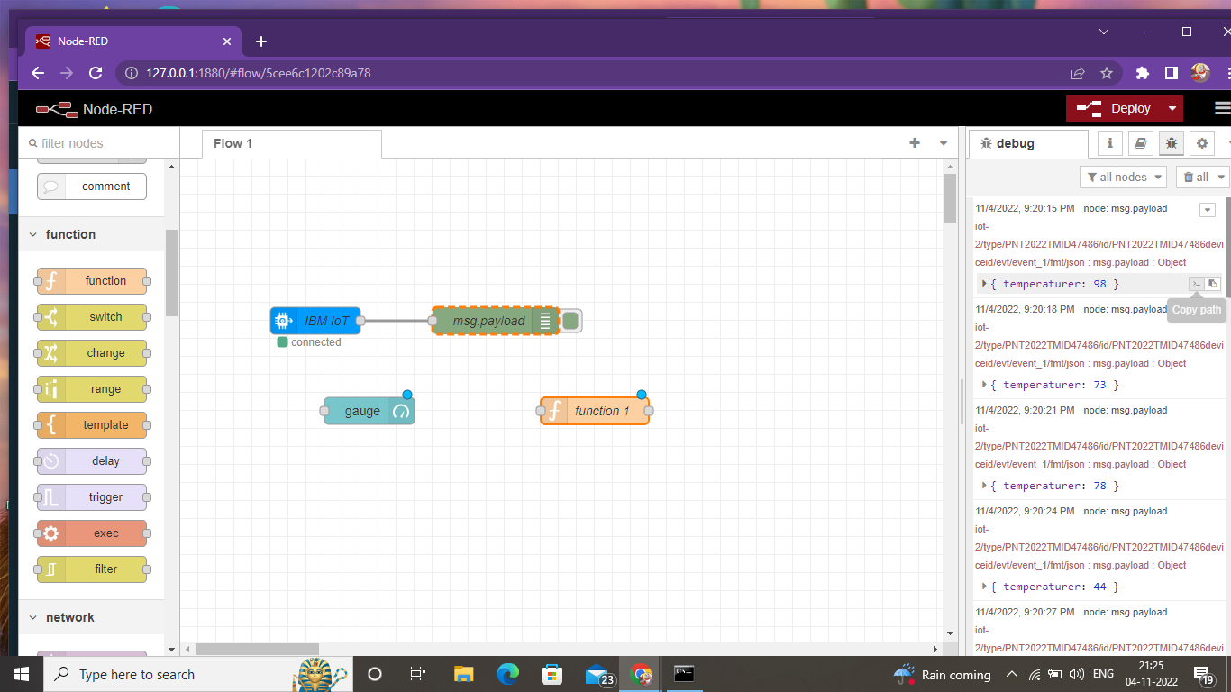

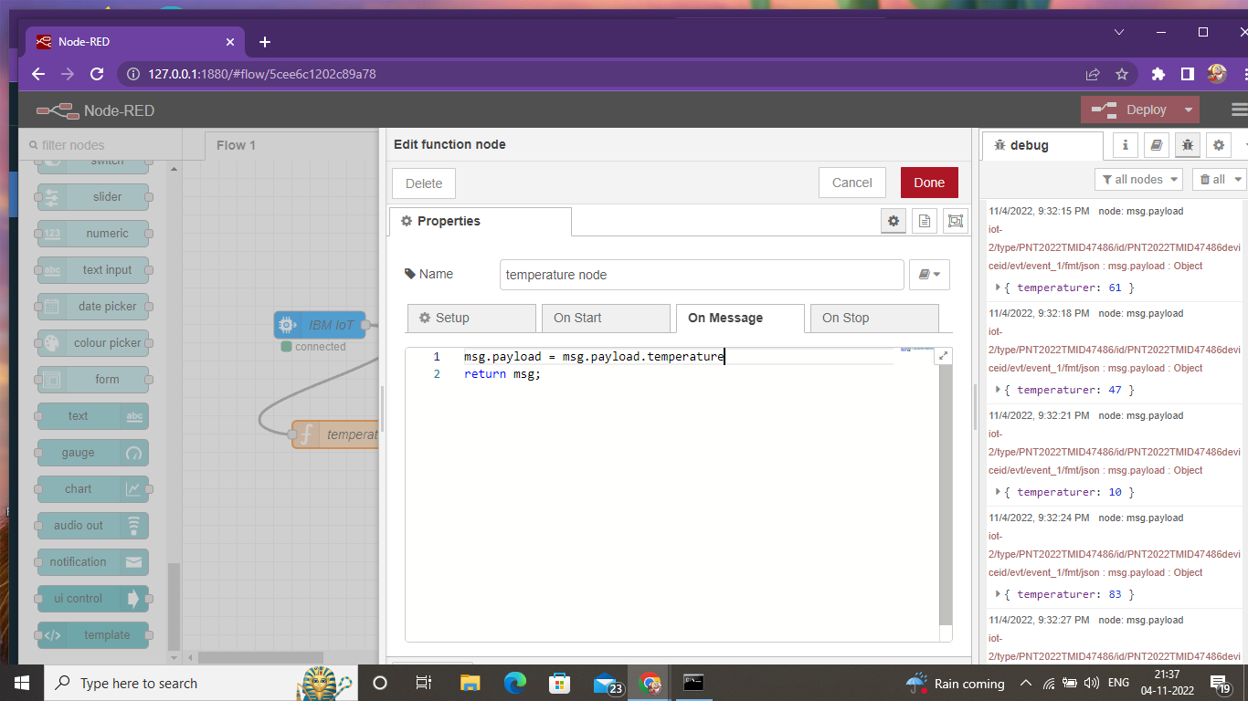

***Step 13: Connect them***

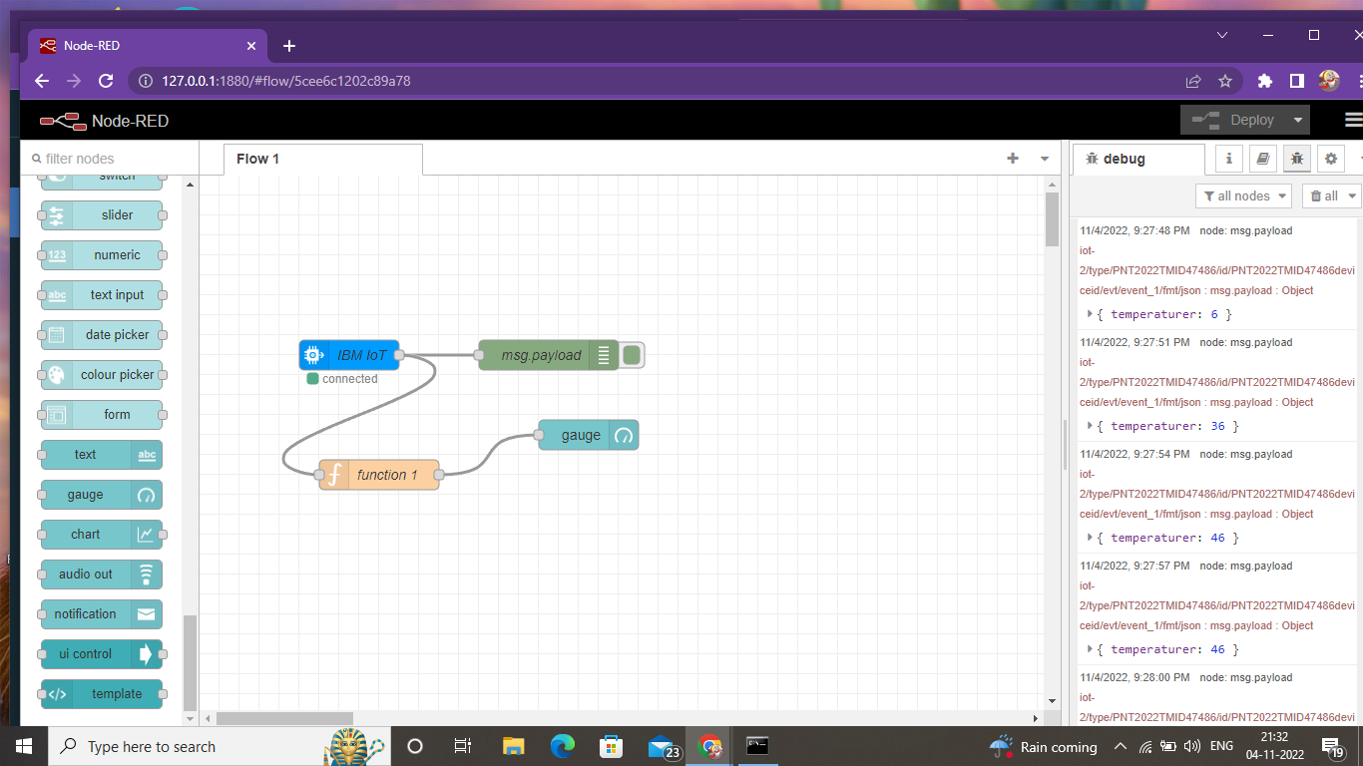

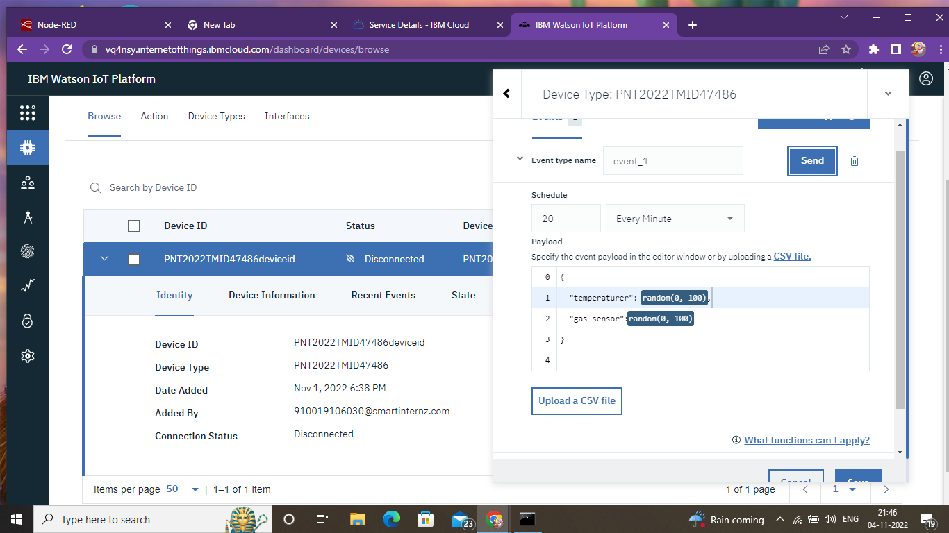

***Step 14: Add another gauge and functions*** 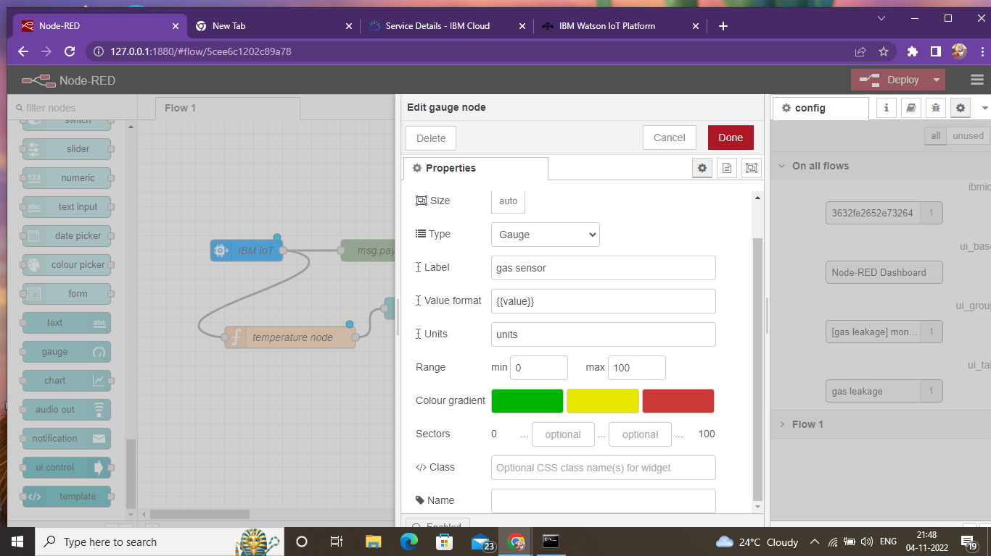

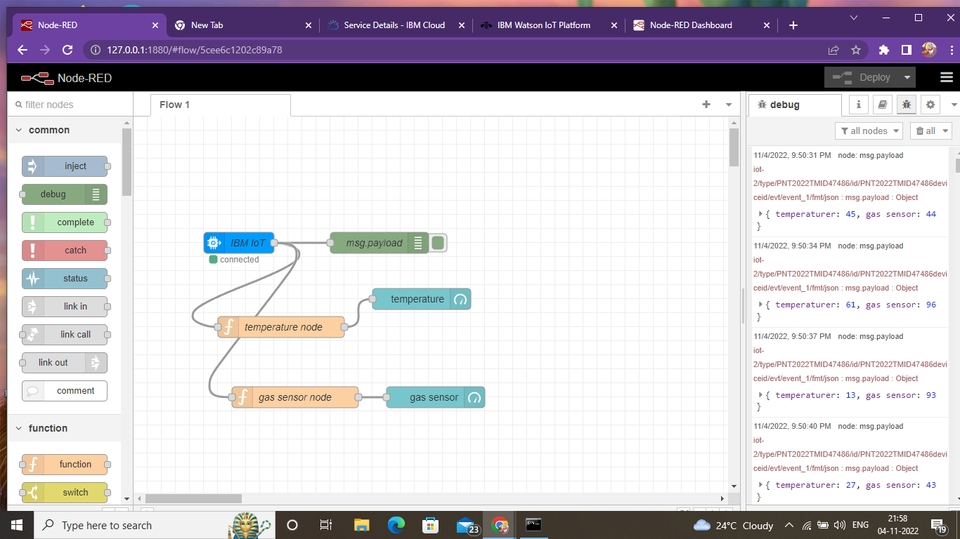

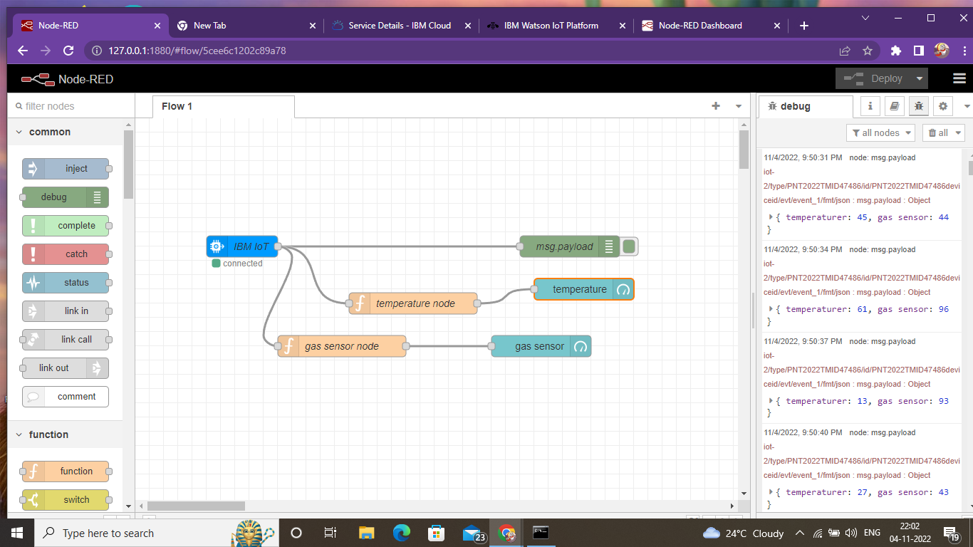

***Step15: finally add alarm on and off buttons to IBM iot and debug.step***

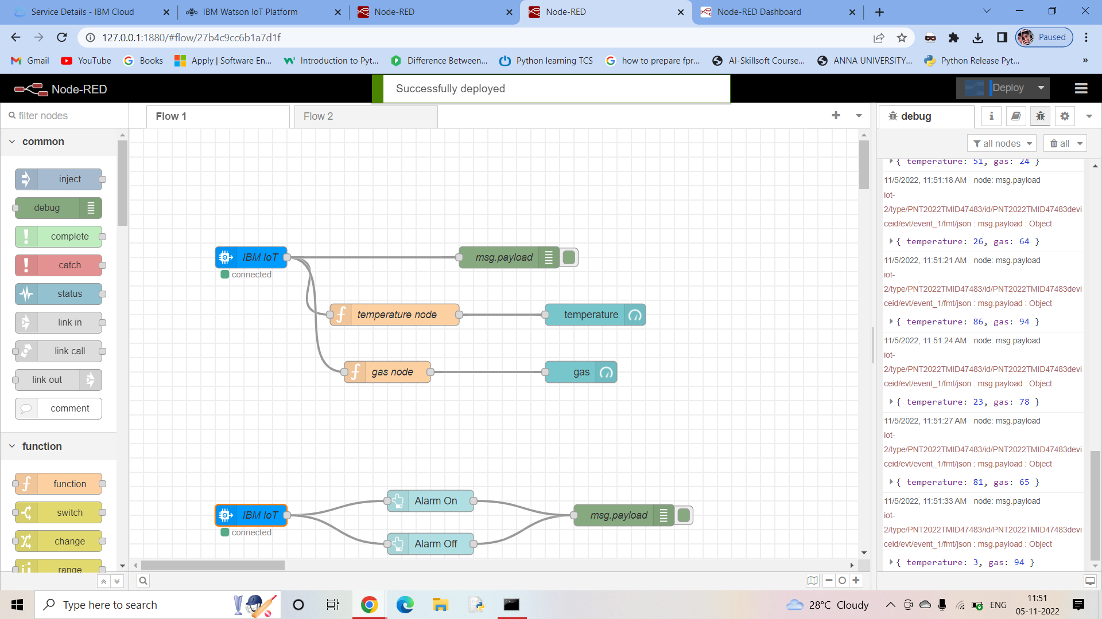

***Step16: Output from node red***

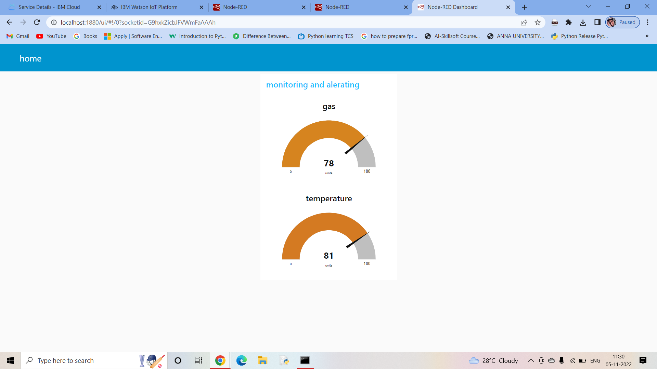

***Step17: Output with light on and off button***

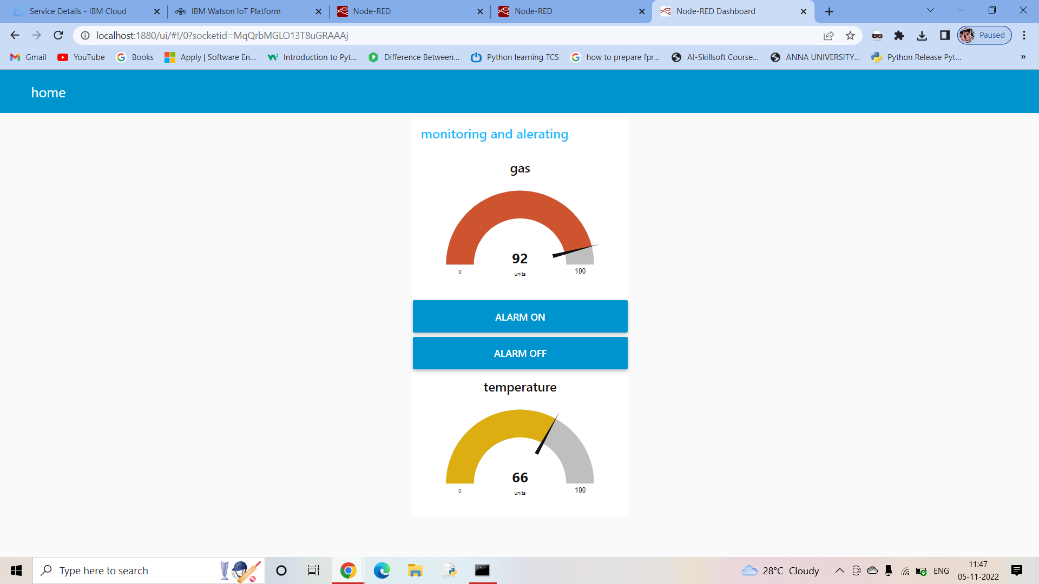

***Step 18: Login to MIT app inventer and design***

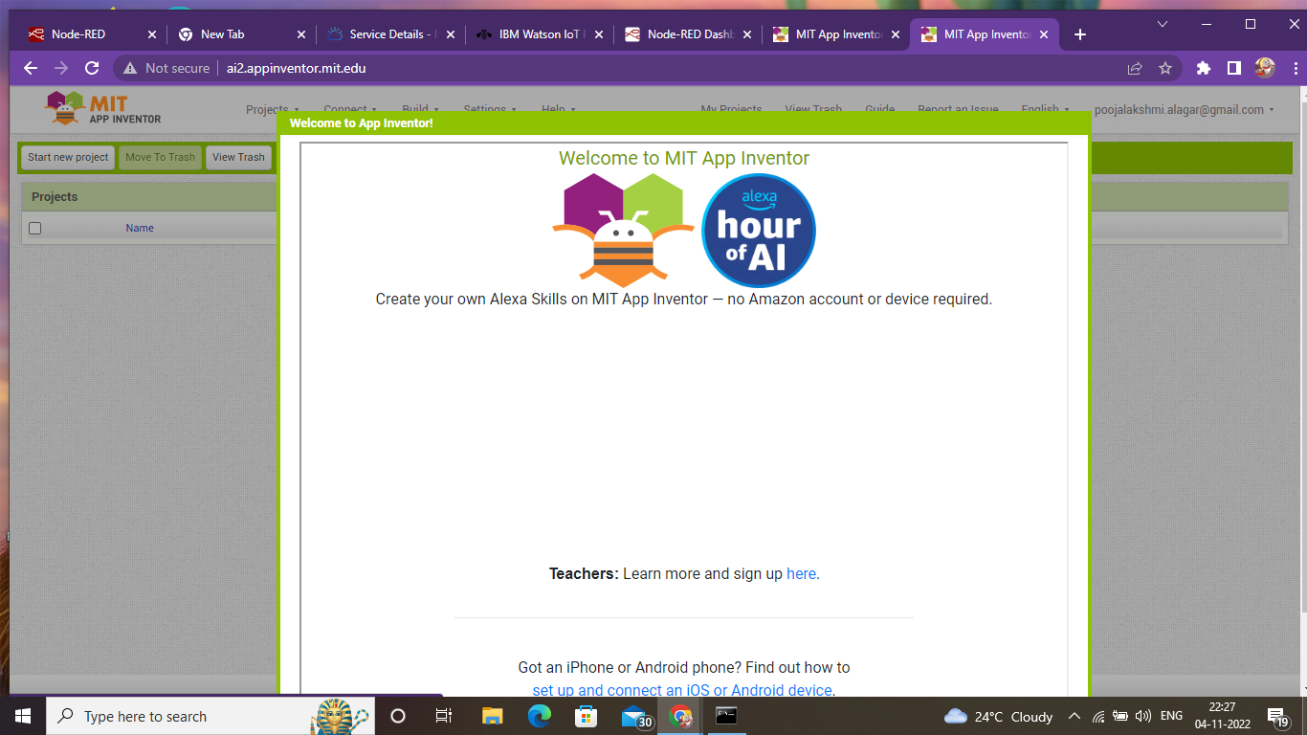

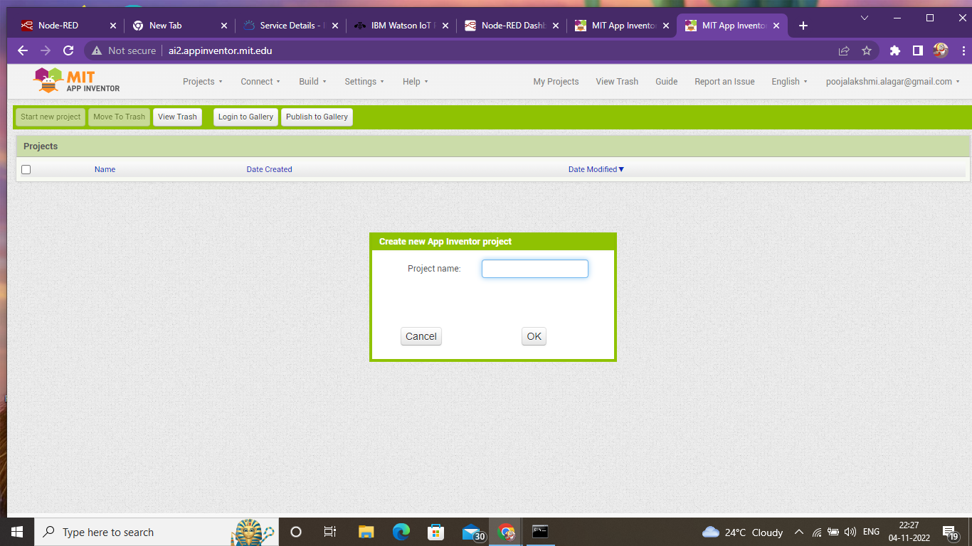

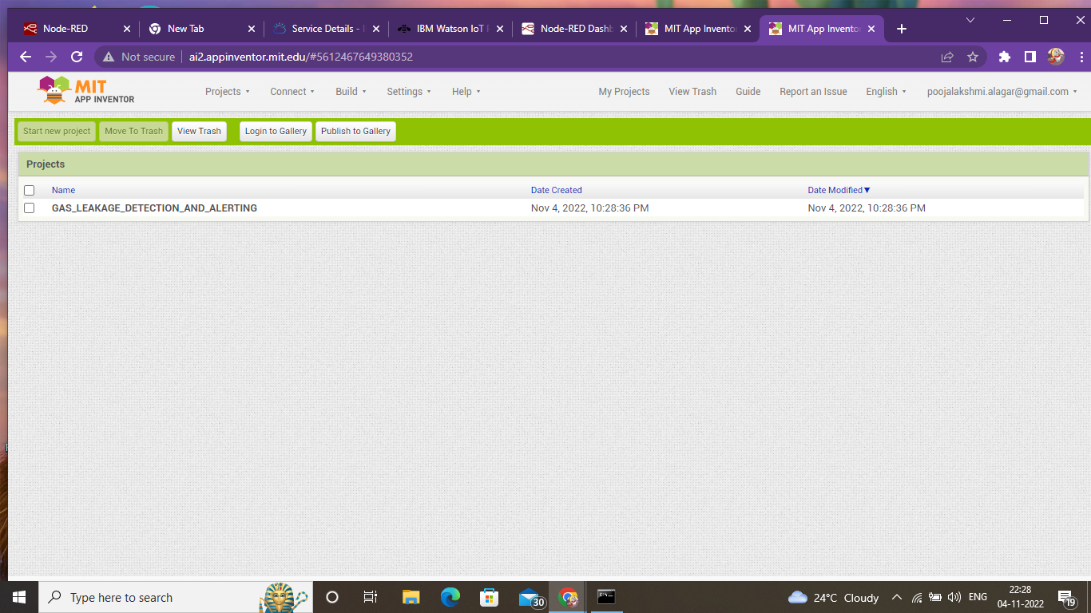

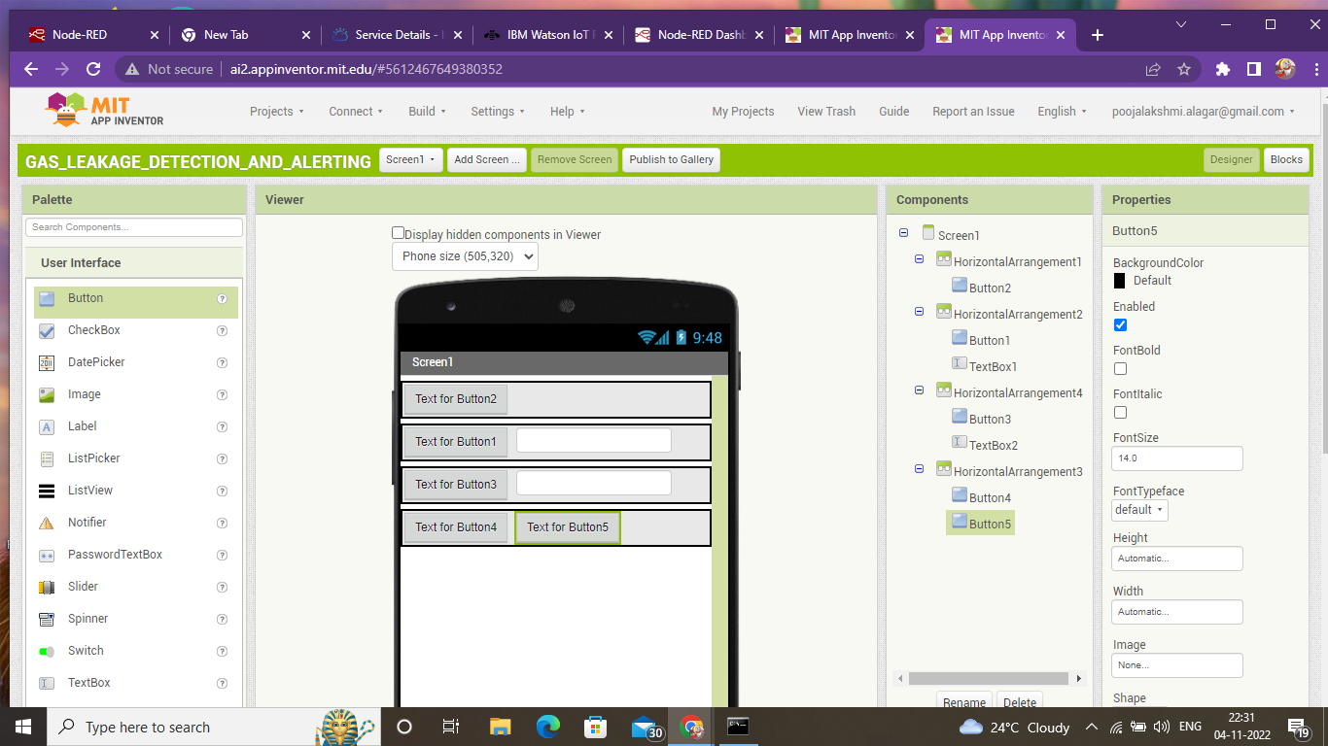

***Step 19: The Output***

